**Experiment :- 2 Macros**

**Definition:** A macro in Excel is a sequence of commands and actions that can be recorded and executed to automate repetitive tasks. It allows users to automate complex processes, save time, and increase efficiency in spreadsheet operations.

Features of macros in Excel:

**1. Automation:**  Macros automate repetitive tasks by recording a sequence of actions performed by the user and replaying them upon request.

**2. Customization:** Users can customize macros to perform specific tasks tailored to their needs, such as formatting data, generating reports, or performing calculations.

**3. Efficiency:** Macros help streamline workflows and increase productivity by reducing the time and effort required to perform repetitive tasks manually.

**4. Versatility:**  Macros can be applied to various aspects of Excel, including data manipulation, formatting, chart creation, and more.

**5. Accessibility:**  Macros are accessible to users of all skill levels, as they can be created using Excel's built-in macro recorder or by writing VBA (Visual Basic for Applications) code.

**6. Error reduction:** By automating tasks, macros minimize the risk of human error that can occur when performing repetitive operations manually.

Overall, macros in Excel provide users with a powerful tool for automating tasks, saving time, and improving productivity in spreadsheet management.

**Starting macro :-**

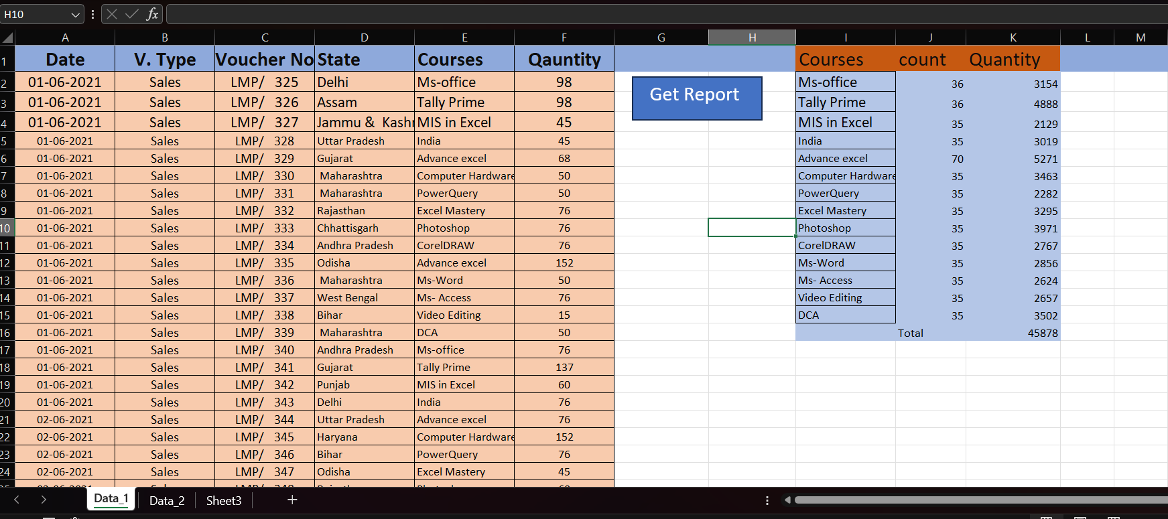

**Applying macro copy :-**

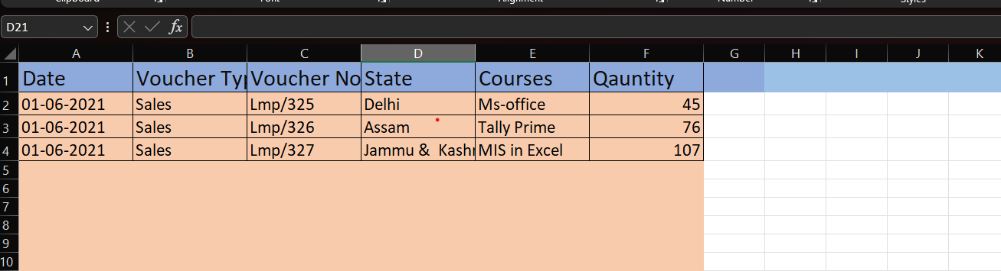

**Applying macro copy :-**

